[2]

[1]



[2]

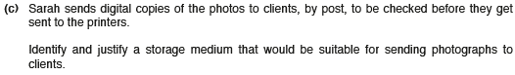

[2]

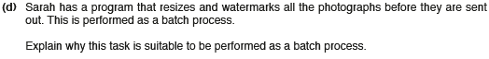

[4]

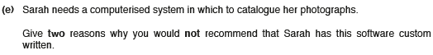

[2]

1

2

[4]



[2]

[2]

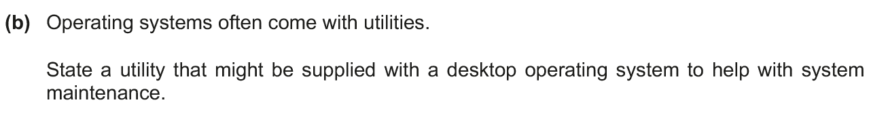

[1]